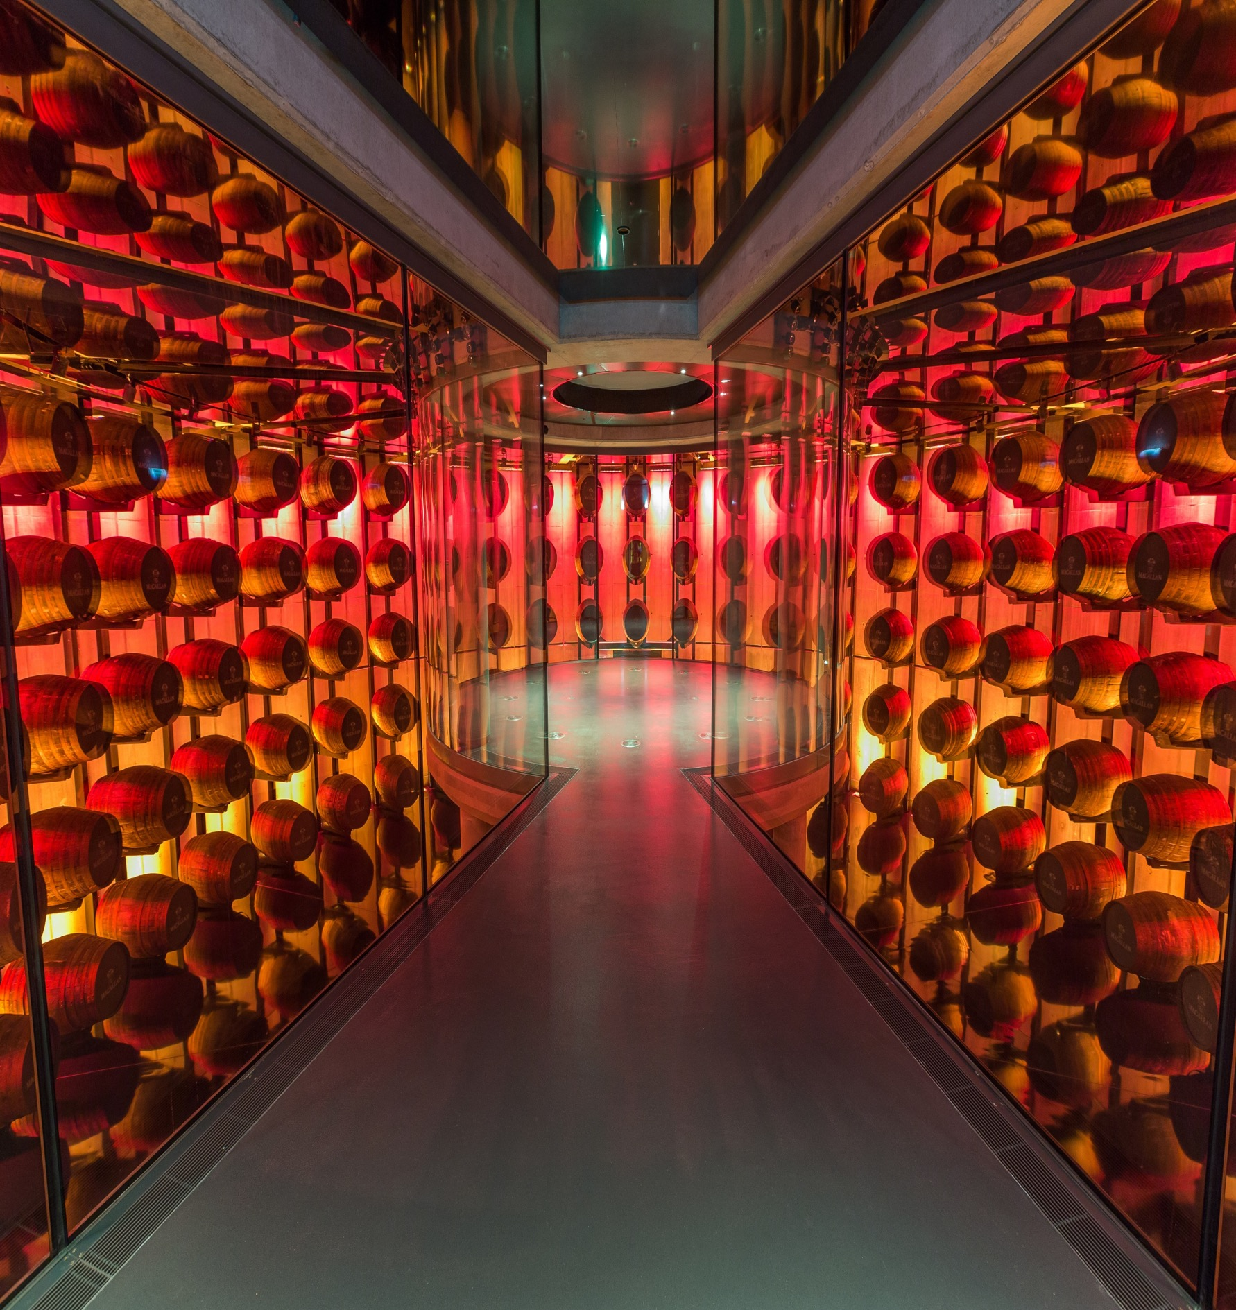
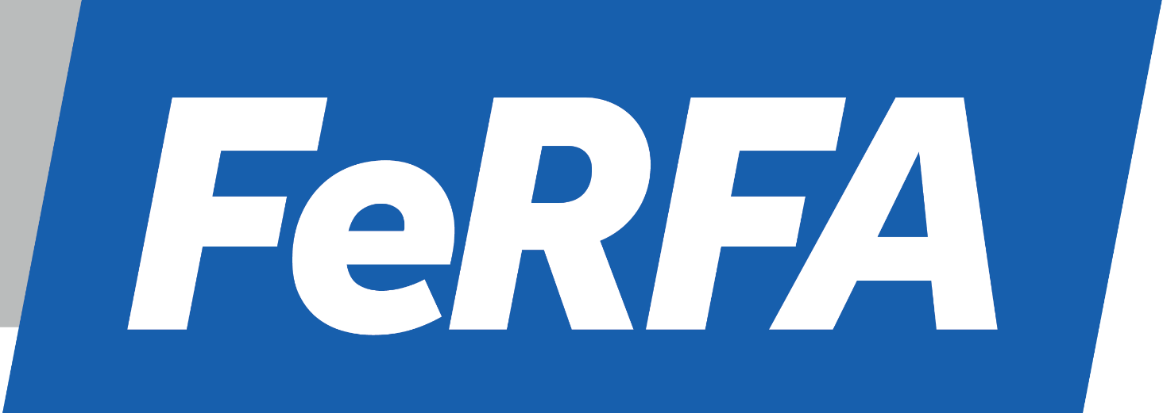
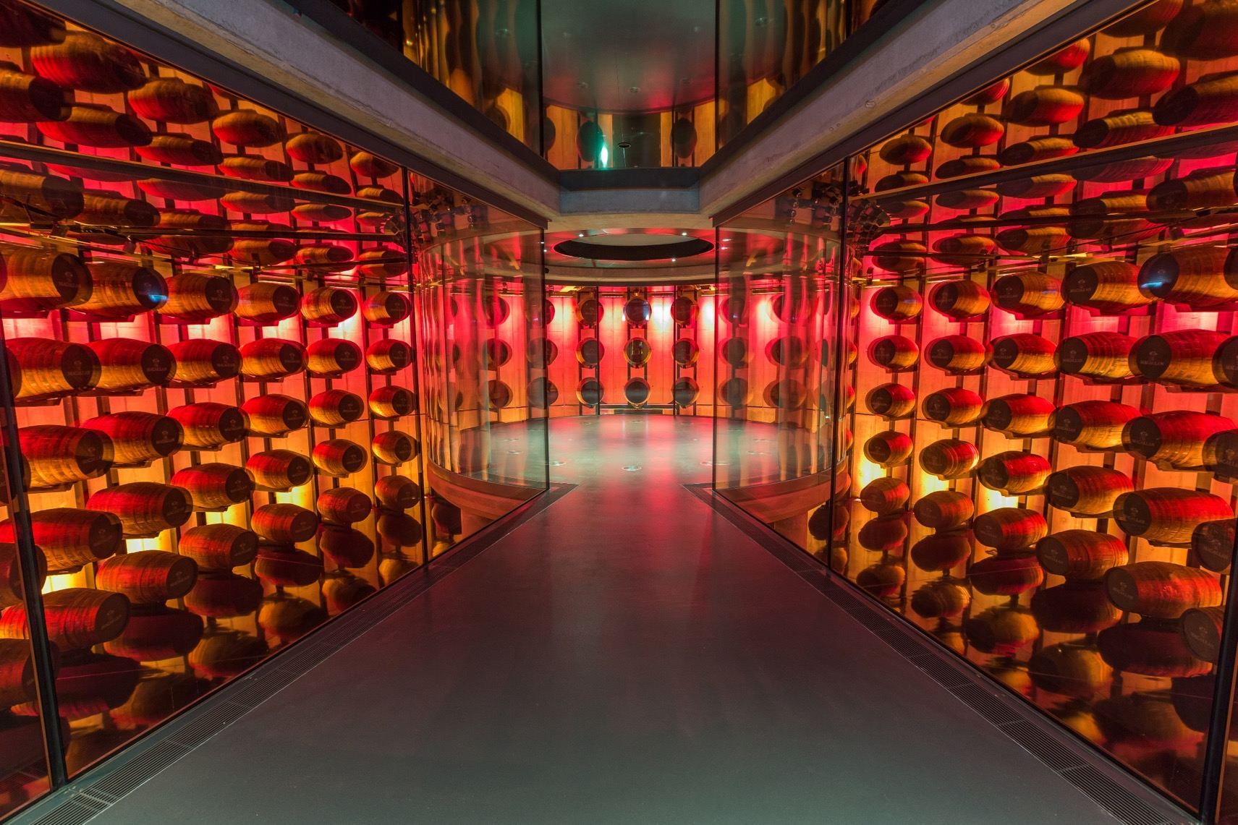
Award Entry Form 2019

LARGE INDUSTRIAL
PROJECT OF THE YEAR

LARGE INDUSTRIAL PROJECT OF THE YEAR – over 1000 m²

RULES OF ENTRY
- This award is open for joint submissions by FeRFA Manufacturer and Contractor members only.
- Eligible projects should have been started or completed during the period 1st October 2018 – 30th September 2019.
- You may enter projects in all categories but use a separate form for each.
- Only one entry is allowed for each combination of manufacturer/contractor in each category.
- It is a condition of entry that material submitted may be reproduced by FeRFA, without charge, in such media that it feels appropriate, to promote the Awards and any other Association activity. Entrants agree to indemnify FeRFA against any claims for breach of copyright as a result of such use.
- In signing this entry form you confirm that you are fully authorised and entitled to sign on behalf of the entrants.

ENTRY & JUDGING PROCESS
- Please provide TWO printed copies of your application for the judging panel (including all attachments) and a copy on USB drive. Large files should be sent via www.wetransfer.com or similar.
- All images should be in jpeg format (minimum 300 dpi). Ensure that all images are identified with the award category and project name.
- You must own the photographs you submit and have full copyright.
- A high-resolution logo must also be submitted with your entry, which will be used in print and online publications.
- In entering the awards, you are warrantying that your entry is truthful and not deliberately misleading.
- The Award Judges will be made up of a panel of FeRFA Associate Members and industry representatives.
- Judges have the right to reject or re-categorise any entry they feel does not comply with the entry requirements. You will be notified if this is the case.
- Any Judge associated with a nomination will be asked to withdraw from the judging process for that category.
- All nominees will be informed if they have been shortlisted.
- The judge’s decision is final.
- Entries close 11th October 2019
- Completed Application Forms and accompanying information should be posted to Natasha Malcolm, FeRFA, PO Box 3716 Stone, Staffs ST15 9EU.

CONTRACTOR | Click or tap here to enter text.
MANUFACTURER | Click or tap here to enter text.
PROJECT NAME (as it should appear in print/on screen at the Awards Ceremony) | Click or tap here to enter text.
PROJECT LOCATION | Click or tap here to enter text.
CLIENT | Click or tap here to enter text.
PROJECT SIZE (m²) | Click or tap here to enter text.
DATE PROJECT STARTED | Click or tap here to enter text.
DATE PROJECT COMPLETED  (if applicable) | Click or tap here to enter text.
PRODUCTS USED (NAME/MANUFACTURER/FeRFA TYPE) | Click or tap here to enter text.
I confirm that this entry has been made in accordance with the Rules of Entry above
NAME | Click or tap here to enter text.
EMAIL ADDRESS | Click or tap here to enter text.
SIGNATURE

Please complete each of the following sections and ensure you provide as much information as possible. Your entry can only be judged on the material you provide You may refer to enclosures where applicable. Images can be pasted onto subsequent pages or supplied separately. Do not provide generic material such as brochures that are not directly relevant as judging time is limited. Superfluous printed material will be ignored by the judges and leads to waste. Please ensure your application fully justifies why the nominated project should win this prestigious award.

1 | Why have you selected this project as a Project of the Year?  Click or tap here to enter text.
2 | Give a brief overview of the project and how you became involved.  Click or tap here to enter text.
3 | Why was resin flooring chosen for this project?  Click or tap here to enter text.
4 | How does this project best highlight your skills and expertise?  Click or tap here to enter text.
5 | Did the project involve any new or innovative products or installation techniques?  Click or tap here to enter text.
6 | Did the project present any challenges such as difficult conditions, size, programme restrictions, aesthetics or performance requirements? How did you overcome these challenges?  Click or tap here to enter text.
7 | Environmental & Sustainability: Please give details of the environmental policy adopted for this project including any data on waste management and recycling. Please include evidence where appropriate.  Click or tap here to enter text.
8 | Health & Safety: Please outline any health & safety issues encountered on this project and how they were overcome and managed.  Click or tap here to enter text.
9 | Training & Staff Development: Please outline any training and staff development initatives used to support and upskill employees involved in this project. Were any FeRFA apprentices either past or present involved in this project? Please include evidence where appropriate.  Click or tap here to enter text.
10 | Why is this the Winning Project? Please summarise in no more than 100 words why this project should win the FeRFA Large Industrial Project of the Year Award 2019.  Click or tap here to enter text.
Please refer to any further information that may be useful to the judges such as case studies, press releases, references from third parties, video clips and testimonial from the client. Ensure these are included in your application. Click or tap here to enter text.

